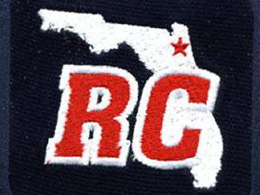

2022 Membership Application

River City Umpires Association
P.O. Box 442031
Jacksonville, FL, 32244

Date:

Name:
Address:

City:
State:
Zip:

Home Phone #: Work Phone #:

Cell Phone #:

Email Address:

Check appropriate box with an “X”: Baseball Softball Both

By my signature, I acknowledge and agree that approval of my application shall not constitute an employment agreement between the River City Umpires Association and myself. Rather that, I will act and be considered as an independent contractor while serving as an association contest official.

Additionally, I agree to be bound and abide by all of the River City Umpires Association By- Laws governing the conduct of an association contest official.

Applicant’s Signature:

