River City Umpires Association Availability Schedule - 2022

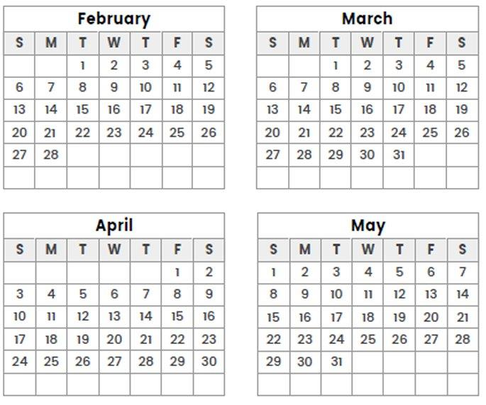
Mark an "X" on Unavailable days
* By leaving a day unchecked you are making yourself available.*

Name: Primary Phone Number: Fax Number:
Comments/Notes:

Are you available for 3:00 PM games?

What part of town will you be coming from?

*It is your responsibility to notify the respective booking commissioner if your availability changes.*

